**Design database for Zen class programme**

1.Find all the topics and tasks which are thought in the month of October.

Solution: db.zenclass.find({users:”student”},{topics:1,taks:1})

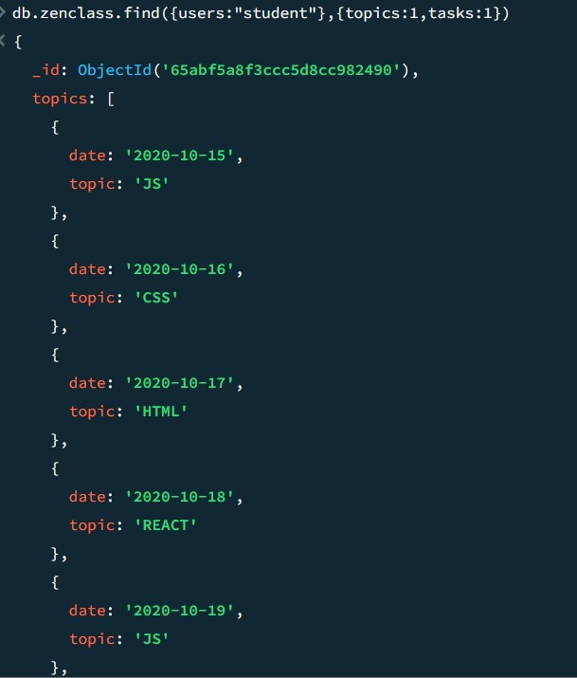

2. Find all the company drives which appeared between 15 oct-2020 and 31-oct-2020

Solution: db.zenclass.find({users : "student"},{company _drives : 1})

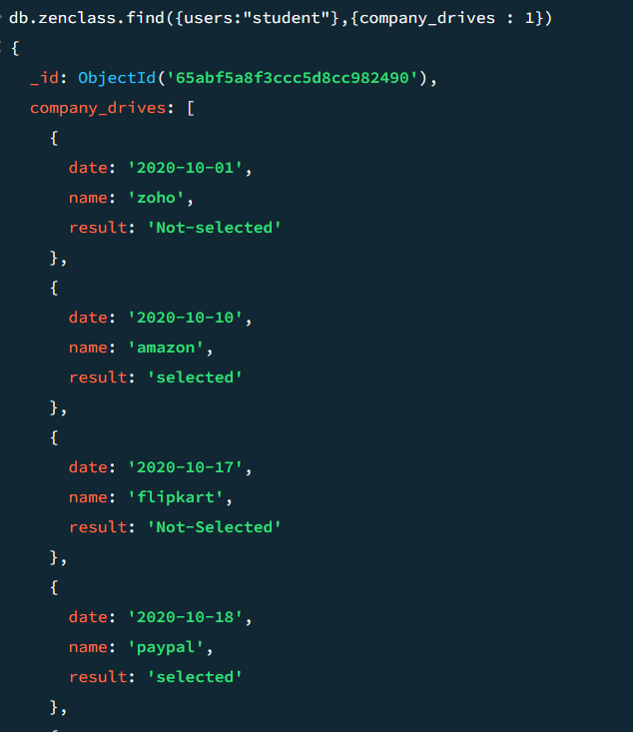

3. Find all the company drives and students who are appeared for the placement.

Solution: db.zenclass.find({users:”student”},{users:0,codekata:0,attendance:0,topics:0,tasks:0} )

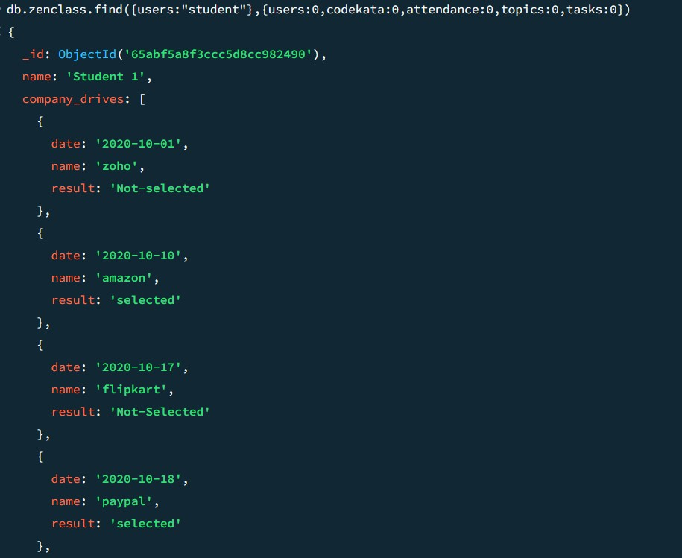

4. Find the number of problems solved by the user in codekata.

Solution: db.zenclass.find({users:”student”},{codekata:1})

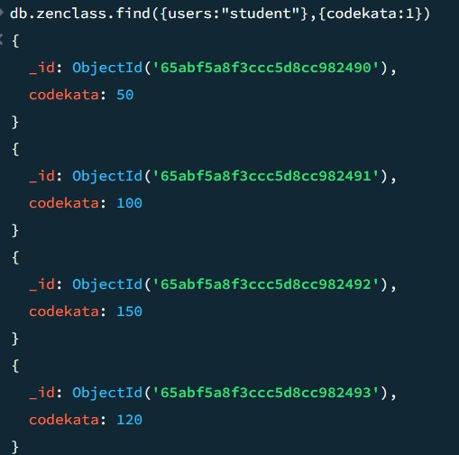

5. Find all the mentors with who has the mentee's count more than 15

Solution:db.zenclass.find({mentee_count:{$gt:15}})

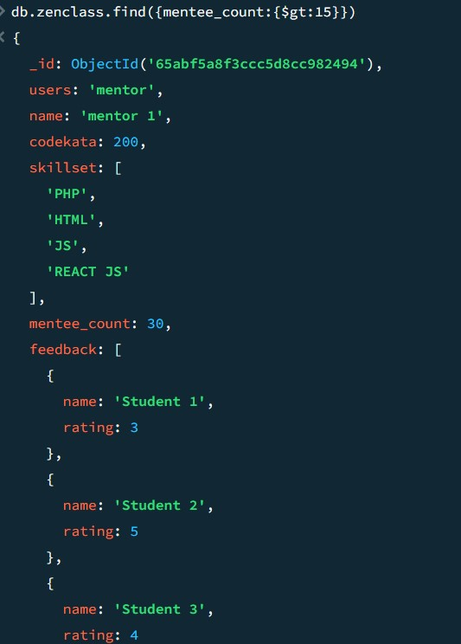

6. Find the number of users who are absent and task is not submitted  between 15 oct-2020 and 31-oct-2020

Solution: db.zenclass.find({users:"student"},{attendance :{ $elemMatch : {status : "absent"}}},{tasks : { $eq: { task :"false" }}})

